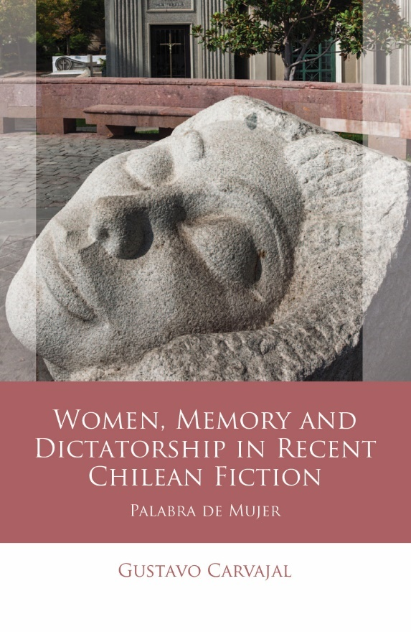
Women, Memory and Dictatorship in Recent Chilean Fiction
Palabra de Mujer

Gustavo Carvajal
November 2021

Women, Memory and Dictatorship in Recent Chilean Fiction discusses the literary representation of women and their memory practices in the recent work of seven contemporary Chilean authors: Diamela Eltit, Carlos Franz, Pía González, Fátima Sime, Arturo Fontaine, Pía Barros and Nona Fernández. It locates their works in the context of a patriarchal politics of memory and commemorative culture in Chile, and as part of a wider body of contested interpretations of General Augusto Pinochet’s military dictatorship (1973–90). Each writer proposes critical narratives that reassess collective representations of the past by emphasising their highly patriarchal nature and the way they marginalise women. It is the only book in English that focuses on women, memory and dictatorship in contemporary Chile and offers a new way of comprehending Chilean memory culture, considering gender and literature as two key elements in this cultural approach to the recent past. The main market for this book is scholars ranging from undergraduates to postgraduates and researchers studying and working on memory cultures in Latin America, and more specifically, Chilean society and memory politics. Since this book approaches memory considering other disciplines such as literary and gender studies, it will also be of interest to students and scholars working across such disciplines.

Gustavo Carvajal is Lecturer in Latin American Literature and Cultural Studies at the Universidad Finis Terrae, Chile.
If you would like to arrange an interview with Gustavo Carvajal, or would like to receive a PDF review copy of the book, please contact:
email: marketingtemppress@press.wales.ac.uk

Women, Memory and Dictatorship in Recent Chilean Fiction: Palabra de Mujer – Gustavo Carvajal – HB – 9781786838032 – £60
Women, Memory and Dictatorship in Recent Chilean Fiction: Palabra de Mujer – Gustavo Carvajal – ePDF – 9781786838049 – £60

CONTENTS:
Series Editors’ Foreword
Acknowledgements
Introduction
Patriarchy and memory
Remembering dictatorial Chile
Women’s memories in the public sphere
Chilean fictions of the traumatic past
1 Violence and Women’s Memories in El Desierto
Rituals of violence and memory
Understanding the traumatic past
Victims and perpetrators
2 Militants, Wives and Mothers in Jamás el Fuego Nunca and Libreta de Familia
The Chilean novel, the dictatorship and the left
The gendered construction of militants and wives
The gendered construction of a mother
3 Female Collaboration in Carne de Perra and La Vida Doble
The Bachelet government
Confessions and conversions
Collaborators in democracy
Telling stories
4 Daughters Rewriting Legacies in ‘El lugar del otro’ and Fuenzalida
Inherited memories
Family albums
Daughters of the dictatorship
Rewriting legacies
Conclusion
Notes
Bibliography
Index

